Linux Commands
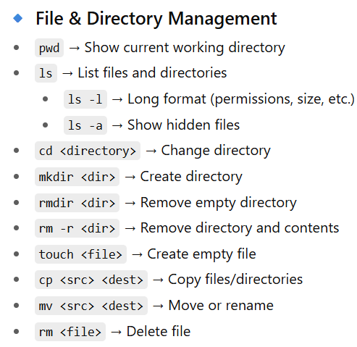
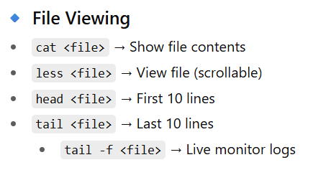
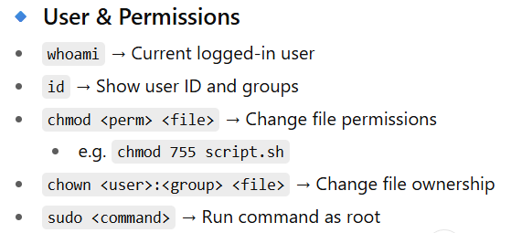
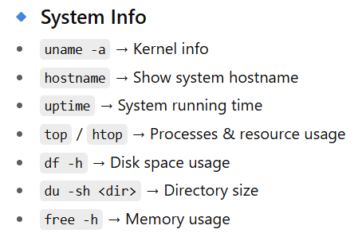
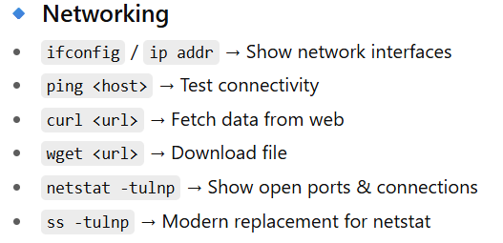
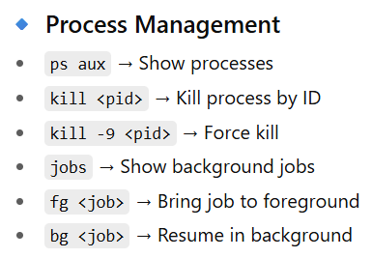
Q. What is sudo apt?
1. apt
- apt = Advanced Package Tool
- It’s the package manager for Debian-based Linux distributions (like Ubuntu, Linux Mint).
- You use it to install, update, and remove software.
2. sudo
- sudo = SuperUser DO
- It allows you to run commands with administrator (root) privileges.
- Package management usually needs root access, so we prefix commands with sudo.

